OOP Final Project Report

***Name:*** Doğukan Avcı

***Student Number:*** 151220202051

***Date:*** 22.12.2024

For this semester's OOP course final project, we developed a project that uses many OOP concepts and OpenCV library to perform line and corner detection.

We used 4 classes to develop our project: **CommonProcesses**, **Detection**, **LineDetection** and **CornerDetection**. We also derived the Detection class from the CommonProcesses class using the **inheritance** operation. We **derived** the LineDetection and CornerDetection classes from the Detection class.

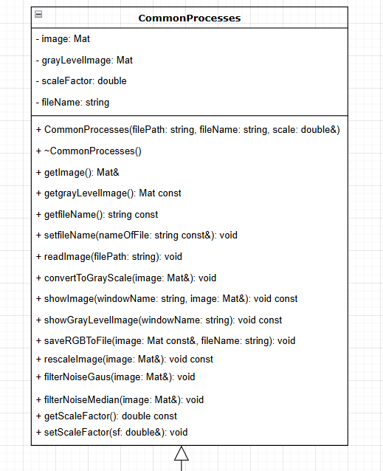As a result, the **CommonProcesses** class is the base class, the Detection class is both a derived and a base class, and the **LineDetection** and **CornerDetection** classes are derived classes.

Figure 1 CommonProcesses UML

Let's start introducing our project with the **CommonProcess** class. In the **CommonProcess** class, we implement functions such as image opening, reading, and filtering, which are frequently used in the field of image processing, and by inheriting these functions, we prevent these operations from being easily used in derived classes and from being rewritten.

The CommonProcess class contains 4 private data members. These are: **image** in **Mat** type, **grayLevelImage** in **Mat** type, **scaleFactor** in **double** type, **fileName** in string **type**.

string and double types are known types that we have worked with before, but I worked with **Mat** type for the first time in the final project. Mat is one of the basic data structures of **OpenCV** library and is used to represent images. In **OpenCV**, an image contains a matrix of pixel values. For Grayscale images, that is, for black and white images (which consist only of gray tones), Mat contains the Gray brightness value of each pixel. We have also covered this topic in detail in the Image Processing lesson. For color images, Matte contains three channels, these channels are called Blue, Green and Red **BGR**. This matrix is ​​used for operations such as reading, processing and saving images.

**Data Members**

* The **image(Mat)** variable holds the main image and represents the image read or processed from the File.
* The **grayLevelImage(Mat)** variable allows us to keep a color image in this variable after converting it to grayscale.
* The **scaleFactor(double)** variable is the scale factor used when resizing dimensions. It is taken from the user.
* The **filename**(string) variable holds the path to the image files. With this variable, you have options when we encode our image.

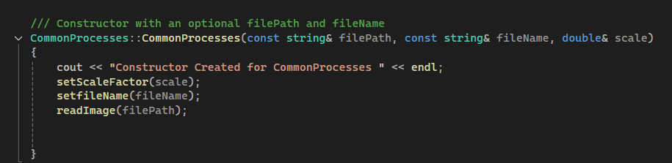**Member Functions**

Figure Constructor For CommonProcesses

**Constructor for CommonProcesses**

* The **CommonProcesses** **constructor** takes **three** parameters as explained above: **filePath**, **fileName** and scale. Then there is a console message in the constructor that the constructor has been created. Then we set the **scaleFactor** and **fileName** variables using the set functions. **We did not use the initializer method** because they have their own **set** member functions. And finally, we read 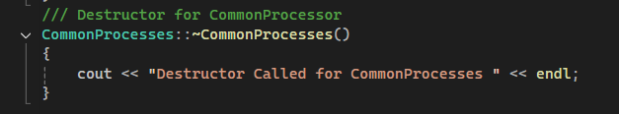our image with the **readImage** member function.

**Destructor For CommonProcesses**

Figure Destructor For CommonProcesses

* We created the **Destructor** empty and it only contains a message to write to the console when called.

Figure getImage Function

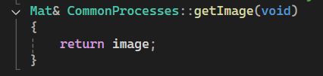

* Since **image** is a private data member, we added a get function to call it in other derived classes and strengthen the encapsulation structure. Since the image file is larger than normal variables, we returned it by reference and saved memory. Since the image variable is of **Mat** type, we returned it as **Mat** type.

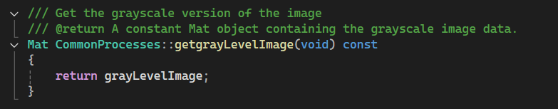

Figure getgrayLevelImage

* Similarly, a get member function was created for **grayLevelImage**.

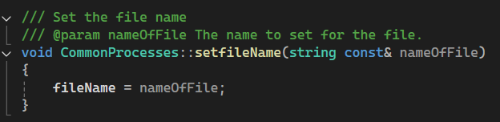

Figure setFileName

* 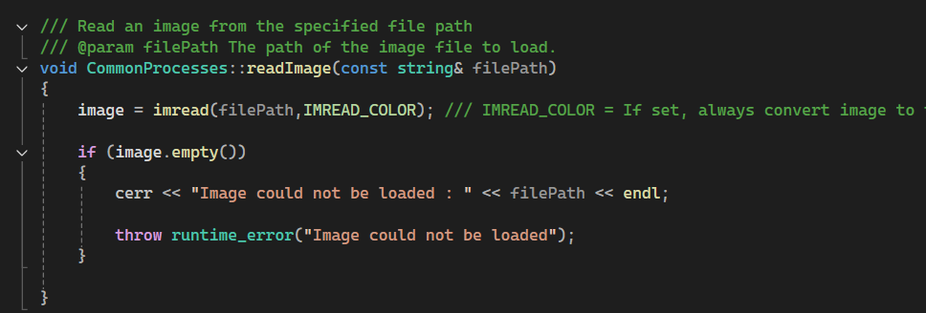The set function was created to assign the **fileName** variable and encapsulation was strengthened.

Figure readImage

* With the help of imread function in OpenCV library, we read the image in our file path and save it to our **2D** array defined with Mat variable. During image file assignment, we check if the file is empty. If the file is empty, we send **runtime_error**.
* 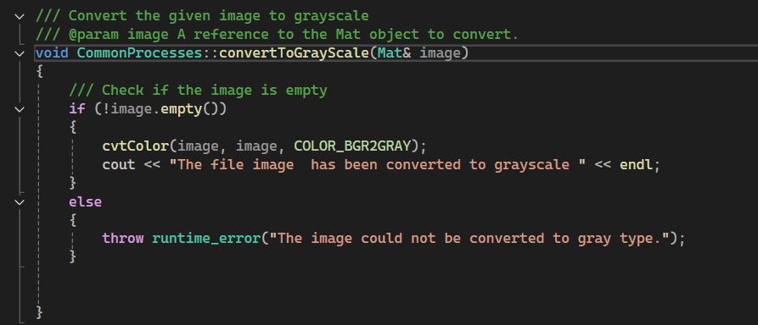Here **IMREAD_COLOR** indicates that the file's color, i.e. **RGB** values, should be read. We can make different readings with other options, for example, we can read the image directly with the grayscale value.

Figure convertToGrayScale

* We convert the **Mat& Image** file that we sent as a reference with the convertToGrayScale function to grayscale value with the **cvtColor** function in OpenCV and write it on the image again. Here, we check again whether the image variable is empty and send **runtime_error** according to the result. Converting the image to gray level is important for algorithms such as the Canny algorithm in the later stages.

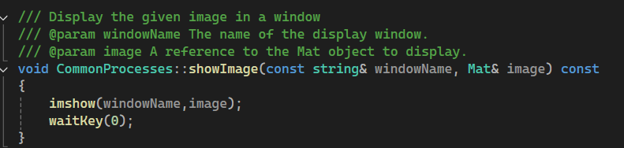

Figure showImage

* The **showImage** member function takes the Image variable as a reference and the window name variable named **windowName** as a reference. With the help of the **imshow** function in the **OpenCV** library, it serves to print the image entered in the specified window name to the screen as output. Later, in order for the images to remain on the screen for a long time, the user is waited to press a key with the **waitKey(0**) in **OpenCV**.

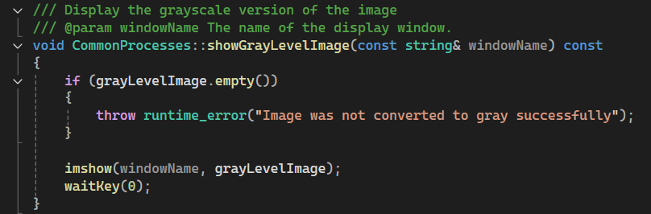

Figure showGrayLevelImage

* To print gray level image screen, it prints gray level image with only window name without any input image value. Error checking is done before printing.

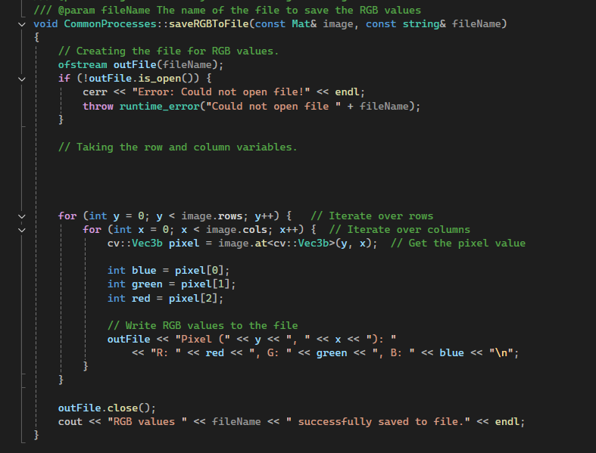

Figure saveRGBToFile

* 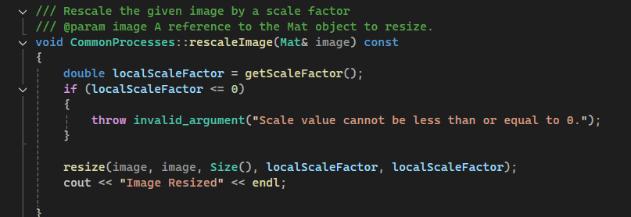With the help of the **fstream** library, we write the **RGB** values ​​of the pixels to the specified file. This function takes the image whose **RGB** values ​​will be written as input. We create an output file with **ofstream** **outFile**. Then we check whether it has been created or not. Then, in nested for loops, we assign these values ​​to the blue, green and red variables. With the help of **outfile<<**, we write the values ​​to the file and finally close our file with **.close()**. Not closing the file may cause certain errors.

Figure rescaleImage

* The **rescaleImage** function takes the image variable as an input value by reference. The reason for this constant change is that the image variability is very large and we do not need to save it constantly. Then, we change the state of the image with the **resize()** function in **OpenCV** and write it back to the image. Before this, we check whether the scale factor is an invalid argument, i.e. a positive value. We throw an error for non-positive indicators.

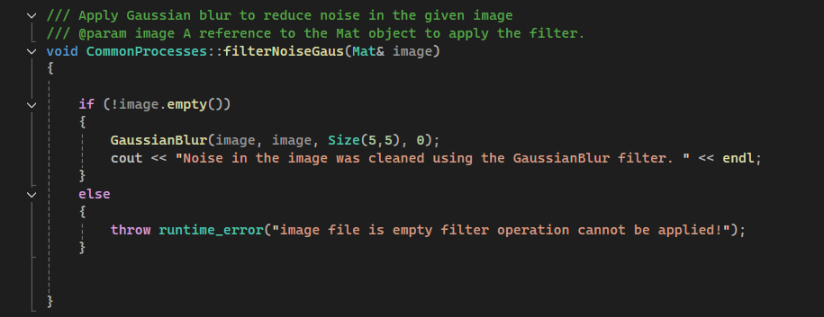

Figure filterNoiseGaus

* In our project, two filter options have been added to add extra functionality. The first filter is the **Gaussian filter**. We can perform this operation thanks to the **GaussianBlur** function in **OpenCV**. First, we check whether our image file is empty or not, and then if the image file is full, we apply the Gaussian operation. The first input in the function is the input, the second input is the output value, and the third value is the size of the Gaussian filter. The Gaussian filter can only have a single-digit number of edges, for example, 3 to 3, 5 to 5, 7 to 7, and the last parameter is the standard deviation, according to which the smoothing rate of the image increases or decreases. The higher the standard deviation value, the higher the smoothing rate of the image.

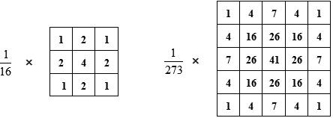

Figure Example of Gausian Filtering

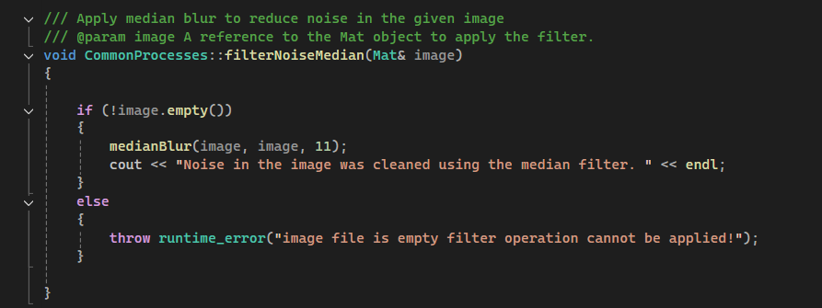

Figure Median Filter

* Another filter used in the project is the **median filter**. This filter, like the Gauss filter, allows the removal of high-frequency pixels on the image. Similarly, the image variable is checked to see if it is empty or not, and we can apply this function thanks to the **medianBlur** function in **OpenCV**. The **medianBlur** function takes 3 different parameters: input, output and filter size. The larger the filter size, the softer the image.

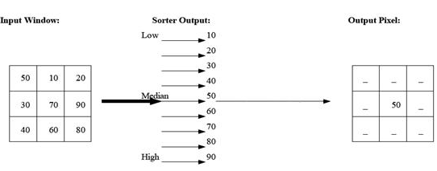

Figure Example of Median Filtering

The images below were produced using the codes in the project:

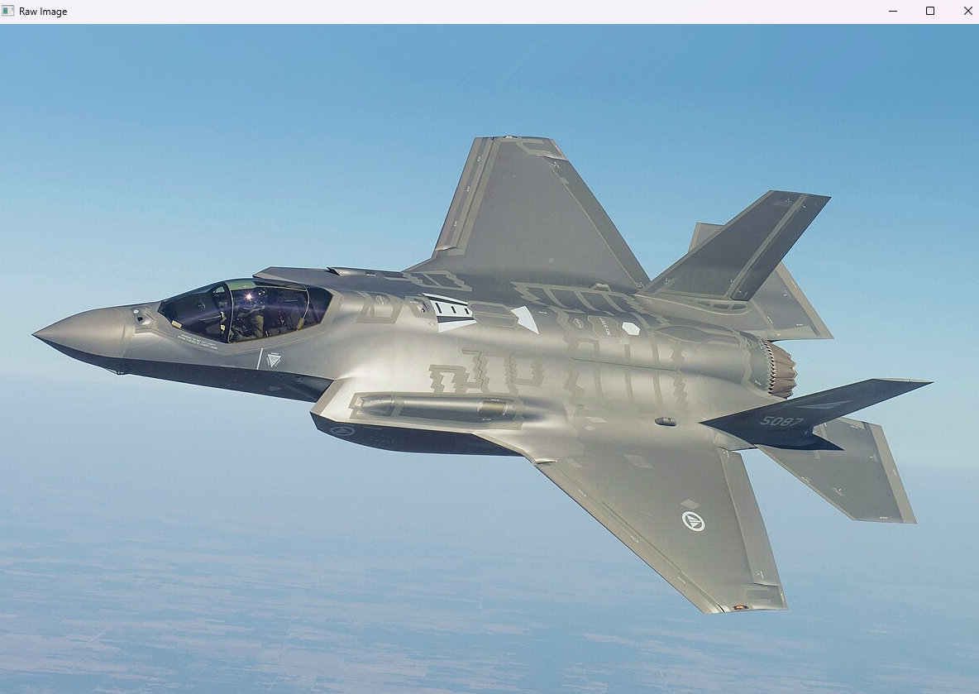

Figure Raw Image

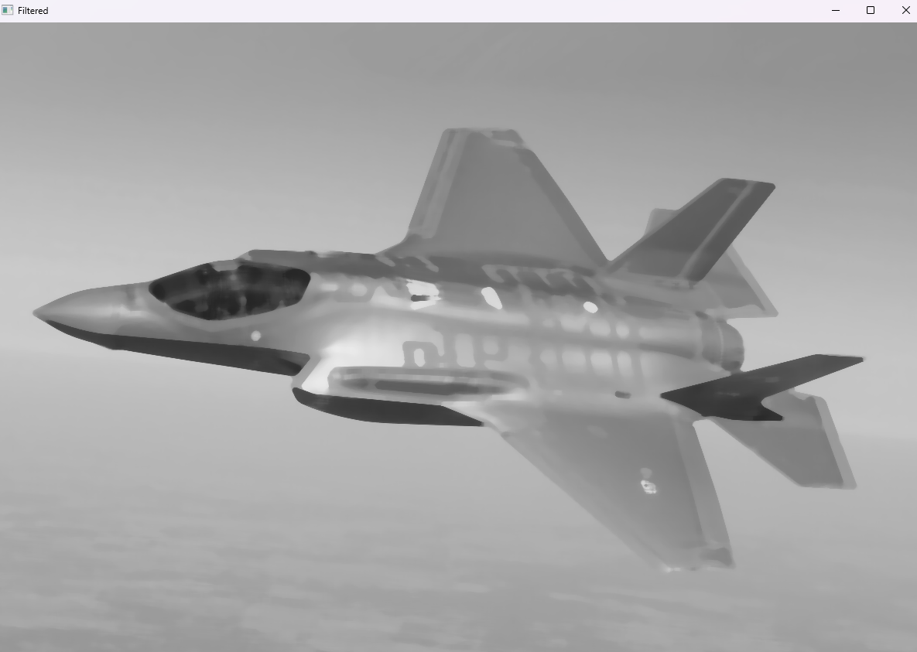

Figure Gaussian 3x3

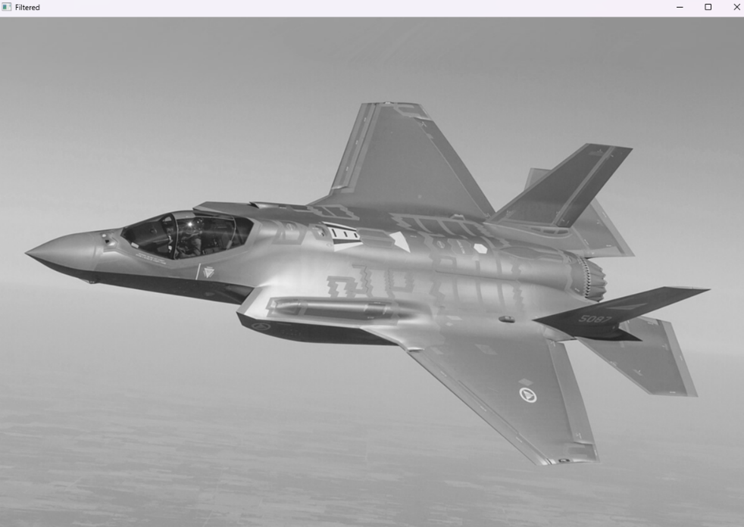

Figure Median 3x3

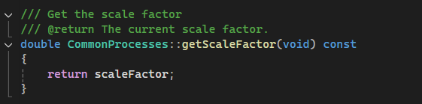

Figure getScaleFactor

* We used this to access the **scalefactor** variable from derived classes and increase **encapsulation**.

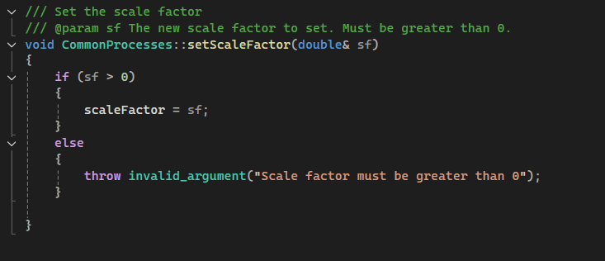

Figure setScaleFactor

* We also added the set member function to assign the **scaleFactor** structure and to check for invalid arguments.

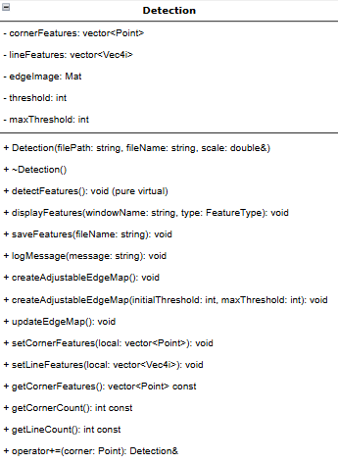**Detection Class**

Figure DetectionClassUML

**Data Members**

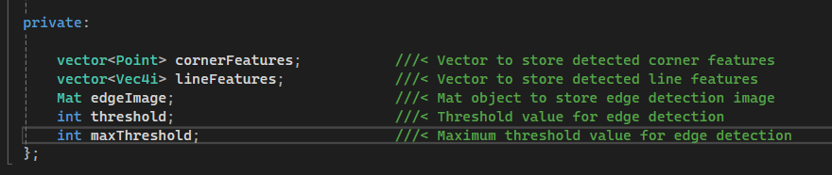

Figure Data members of Detection Class

* **CornerFeatures** (vector<Point>) is a vector that stores the corner points detected in the image. Each point is stored as a Point object. This variable is updated with **setCornerFeatures()** after the corner settings.
* The **lineFeatures**(vector<Vec4i>) variable stores the lines detected in the image. Each line is stored as a Vec4i representing the start and end points. After line detection, it is provided with the setLineFeatures() method.
* **edgeImage** (Mat) Stores the image created as a result of edge detection. It is updated with the updateEdgeMap() function and created with the Canny edge detection algorithm.
* **threshold** (int) minimum threshold value used for edge detection. The user can change this value via an interactive trackbar.
* **maxThreshold** (int) The maximum threshold that can be used for edge detection. Creates a boundary for the trackbar.

**Vec4i** is also a data type that we encountered for the first time, just like Mat. Vec4i is one of the basic data types provided by **OpenCV**. This data type means a vector of four integers. Its full name can be explained as "**Vector of 4 Integers**". It is used to specify lines in algorithms such as Hough transform.

**Member Functions**

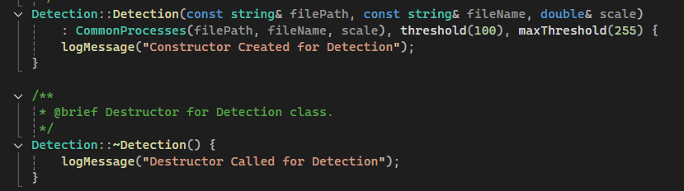

Figure Constructor and Destructor for Detection

* 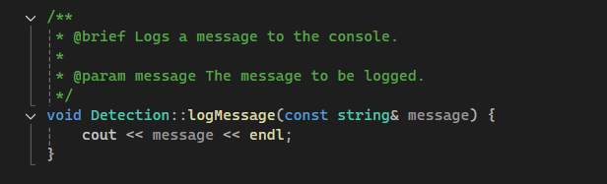In Detection Constructor, constructor was created with the help of **logmessage** function written in the project and threshold and **maxThreshold** values ​​were assigned with initializer method. Similarly, since Detection is a derived class, **CommonProcesses** Class also needs to be defined. We define **CommonProcesses** class with **FilePath**, **fileName** and scale values. Then we add **Destructo**r and we can check whether it is called with **logMessage** function or not from console screen.

Figure logMessage member function

* The **logMessage** function takes the message variable with its address in string type and prints it with cout. It was added to the code for ease of reading and easier application.

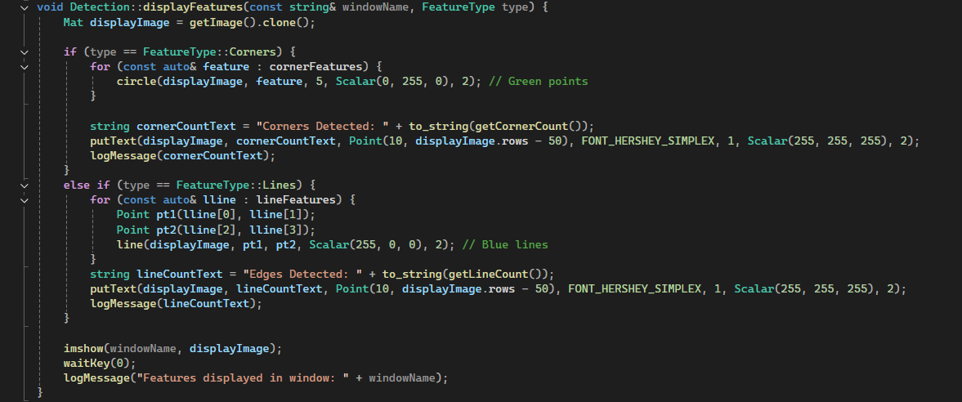

Figure Display Features Function

* The **disPlayFeatures** function allows any features (corner, edge) to be displayed with certain marks when encountered. For example, this function takes the **FeatureType** property as input. It takes into account the conditions within the feature type property and if it is a corner, it marks all the feature values ​​within **cornerFeatures** with the circle function in **OpenCV**. The first input shows which image to use, the other input shows the features, the others express the circle diameter, color and thickness respectively. The same operations are done for the line. Each line feature is drawn with the line function in **OpenCV**.

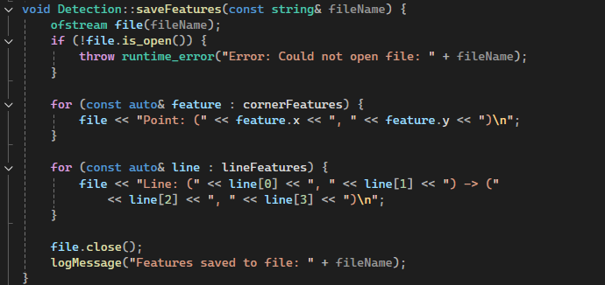

Figure saveFeatures

* Thanks to the **saveFeatures** function, we use the **fstream** library that we have explained before and save the found corner and line feature values ​​to our file. Then, we close the file again and print the log message. This function also takes the **fileName** with its address as the input value.

***FILE OUTPUT :***

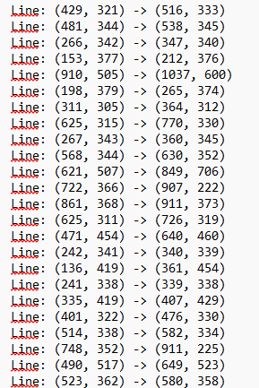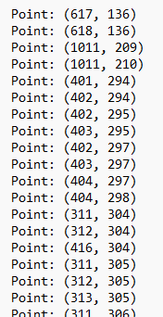

Figure 29 Saved Line Values

Figure 28 Saved Point Values

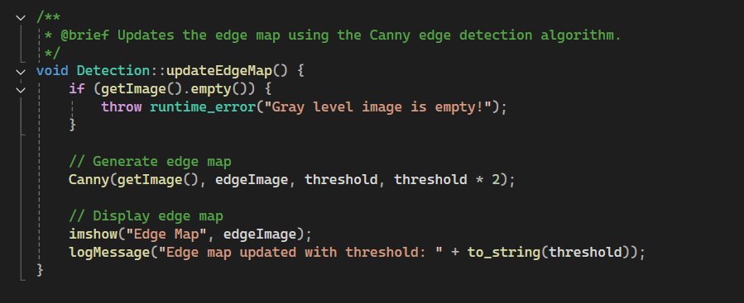

Figure Update Edge Map

The **updateEdgeMap** function checks if it is empty using the **getImage** member function. If it is empty, it sends an error. Then, the **Canny** function in **OpenCV** continuously finds the edges according to the specified threshold values ​​and records this to the **edgeImage** variable. The updated thresh hold values ​​are sent as a log message and the new image is printed on the screen with the **imshow** function.

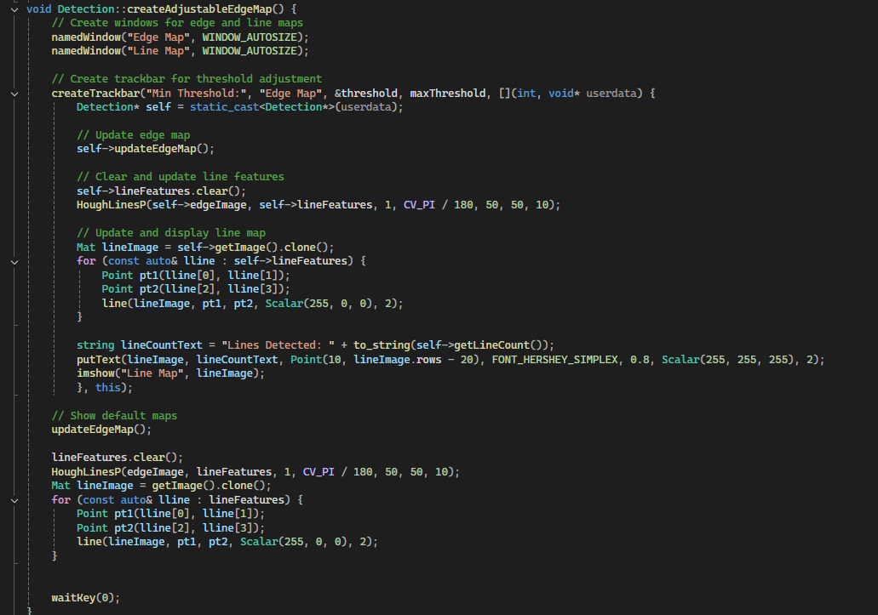

Figure createAdjutableEdgeMap

This function allows the user to **interactively adjust** the edge detection map and line map of an image. Two windows are created inside the function, a trackbar is added to change a threshold value, and the detected lines are displayed dynamically. It allows us to create an **EdgeMap** that can be adjusted according to the threshold value. We create two windows called **EdgeMap** and **LineMap** with the **namedWindow** function in **OpenCV**. Again, we can create an adjustable bar with the **createTrackbar** function in the **OpenCV** library. The first input value of this bar is the text file that should be written to the left of the bar, namely **"Min Threshold"**, the second parameter is the window name **"Edge Map"**, the threshold value set by the user is kept in the **&threshold** variable. The **maxThreshold** value holds the maximum threshold limit. The **Lambda function** is the callback function to be called when the trackbar moves.

Detection* self = static_cast<Detection*>(userdata);

In this line, we assign a pointer to the Detection object. The goal is to reach the this pointer and access other members of the class.

A new edge map is drawn in the **updateEdgeMap** function according to the threshold value. Then the line features are cleaned and new line values ​​are created according to the new threshold value. Lines are detected with the HoughLinesP function in OpenCV and the detected features are stored in lineFeatures. CV_PI/180 angle resolution, 50 minimum vote requirement 10 minimum spacing of lines. 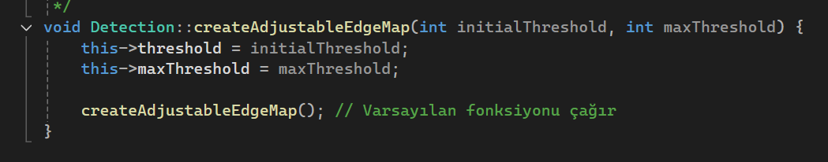

Figure createAdjustableEdgeMap

* 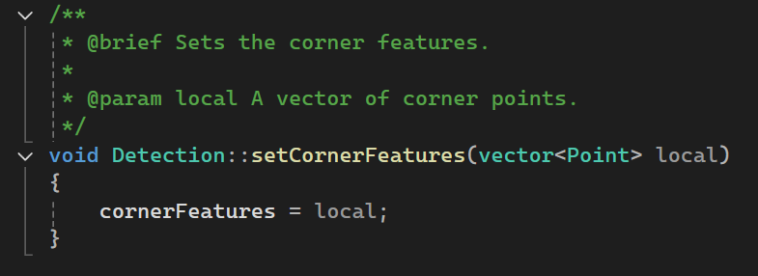Here, we rewrite the **createAdjustableEdgeMap** function, which is one of the best features of C++, by overloading the function. Here, the user can perform more specific operations and operations in smaller ranges by specifying special threshold values. If he calls the same function by giving parameters.

Figure setCornerFeatures

We can set the **CornerFeatures** values ​​with the help of this function and make it possible to perform this assignment in derived classes as well. Because the **CornerFeatures** variable is **private**.

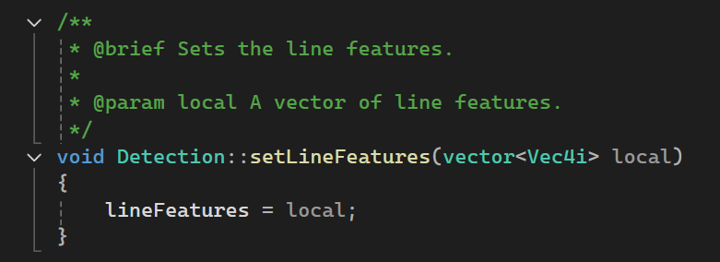

Figure setLineFeatures

* Likewise, we wrote the **set** member function to set the **LineFeatures** variable from derived classes.

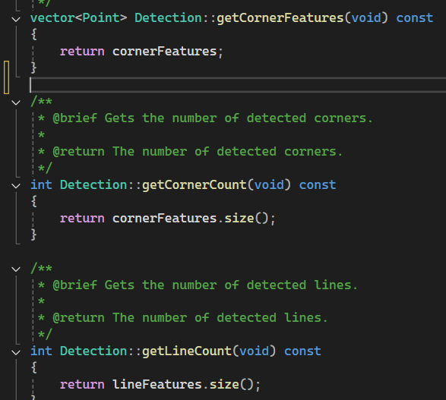

Figure Other getFunctions in Detection Class

* In order to return the detected vertex and line numbers to the user in an easy way and to further strengthen the **OOP structure**, we returned the detected vertex and line numbers with the help of the **.size()** function.

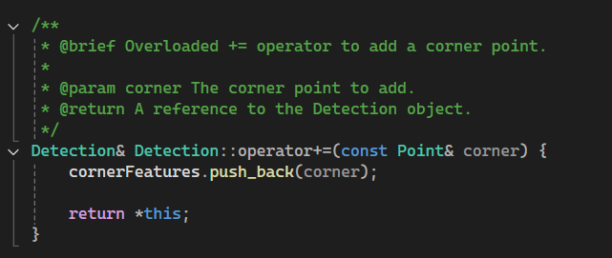

Figure Operator Overload

* In order to add new elements to the **cornerFeatures** vector more easily and conveniently, we overloaded the **+=** operator and added the value behind the vector with **.push_back(corner).** In this way, the **+** operator can also be used between **Point** objects.

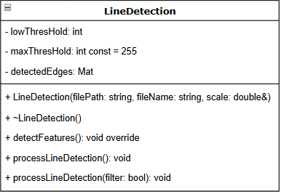**LineDetection Class**

Figure LineDetection Class

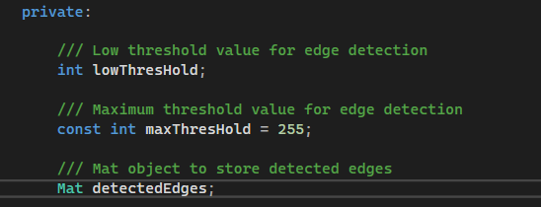

Figure Variables of LineDetection Class

* The **lowThreshHold** value is used to store the low threshold value.
* The **maxThreshold** value holds the maximum threshold value. As can be seen from the picture, we fixed it to **255**. Since it is const, we initialized it in the header file.
* The **detectedEdges** variable is a **Mat** variable and stores the detected edges.

**Member Functions**

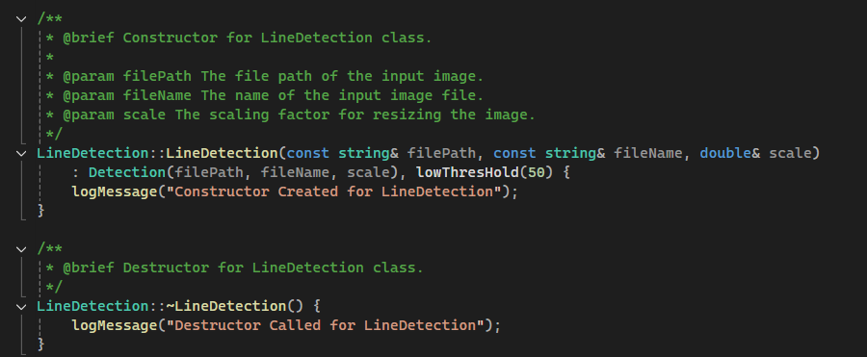

Figure Constructor and Destructor for LineDetections

* When called in **Constructor** and **Destructor**, it prints a log message to the screen. Since the **LineDetection** Class is generated from the **Detection class**, we define the Detection class as the **initializer** method. And finally, we define the **lowThreshold** value as **50**.

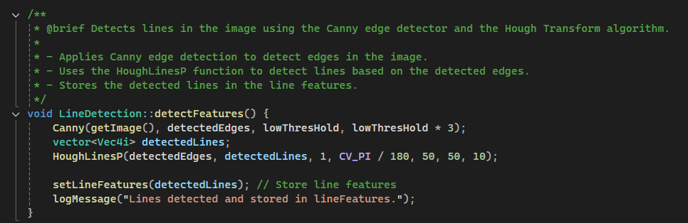

Figure detectFeatures

* We perform line detection with the **detectFeatures** function, first we perform edge detection with the **Canny** function in **OpenCV**. The **Canny** function was mentioned earlier in the report. Then the detected edges are transferred to the **detectedLines**, which is a 4-parameter vector, with **HoughLinesP** in **OpenCV**, and set with the set function. Finally, the log message is printed on the screen that the process is completed.

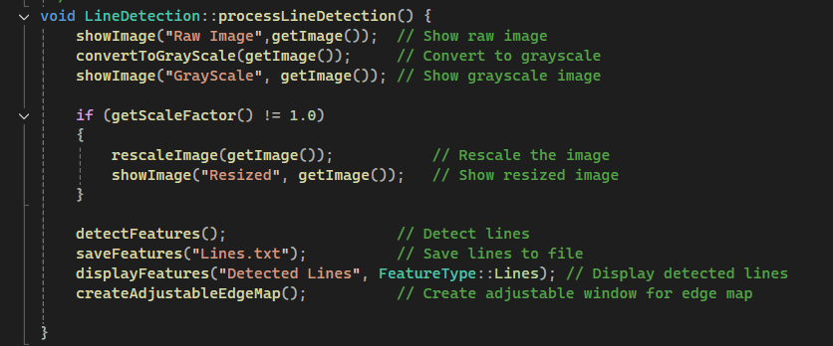

Figure processLineDetection

It is a function that carries out the line detection event completely from beginning to end by containing all the written functions. It suppresses the function with **showImage**. Then, it converts the image to gray level with the **convertToGrayScale** function, that is, it manipulates the image. Then, **GrayScale** suppresses the image. Then, it calls the scale factor with the get function and checks if it has changed. If it has changed, it changes the size of the image with the **rescaleImage** function. Then, it detects the lines with the **detectFeatures()** function and saves them to Lines.txt with the help of **saveFeatures("Lines.txt").** It also shows the lines on the image with the **displayFeatures** function. Finally, it prints an image whose threshold value can be controlled with the **createAdjustableEdgeMap()** function.

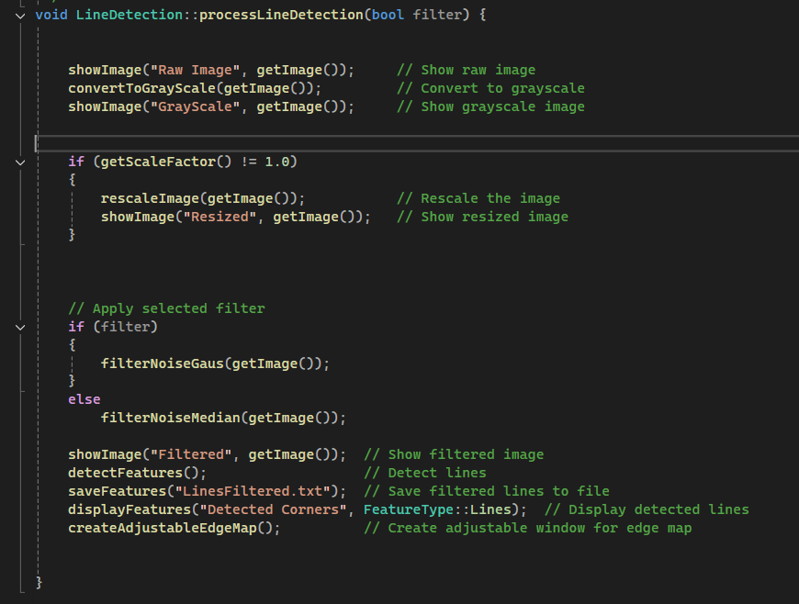

Figure processLineDetection overloaded

Here, unlike the first **processLineDetection** function, we take a **bool** value as input. And according to this value, in addition to the previous steps, we apply the filter operations in **CommonProcesses** before the detection process. If **TRUE** or **1** is entered, the Gaussian filter is applied with the **filterNoiseGaus()** function. If **FALSE** or **0** is entered, the median filter is applied with the **filterNoiseMedyan()** function, reducing high-frequency noise and smoothing the image.

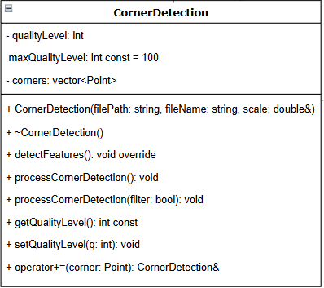**CornerDetection**

Figure Corner Detection UML

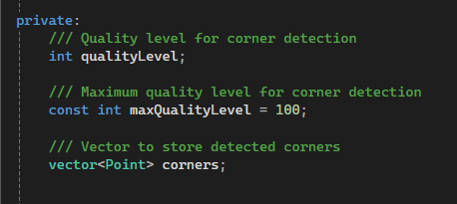

Figure CornerDetection Class variables

**Variables**

* **qualityLevel** Determines the quality level used in corner detection. This value represents the minimum quality level of detected corners.
* const int **maxQualityLevel** = **100**: The maximum quality level setting that can be set for corner details and is a fixed value.
* **vector<Point> corners**: A vector that stores the coordinates of the detected corners. Each corner is stored as a Point object representing its **(x, y)** coordinates.

**Member Functions**

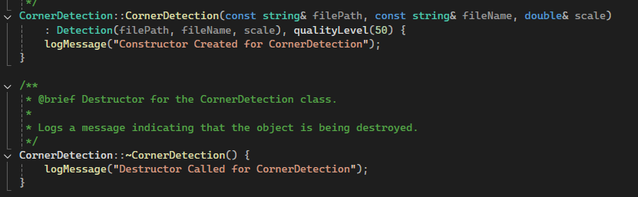

Figure Constructor and Destructor For CornerDetection

Since the **Cornerdetection** class is generated from the **Detection** class, we defined the Detection class with the initializer list method just like **Linedetection** and then we defined the **qualityLevel** variable with 50. We checked from the console whether the Constructor and Destructor were called with the **LogMessage** function we wrote earlier.

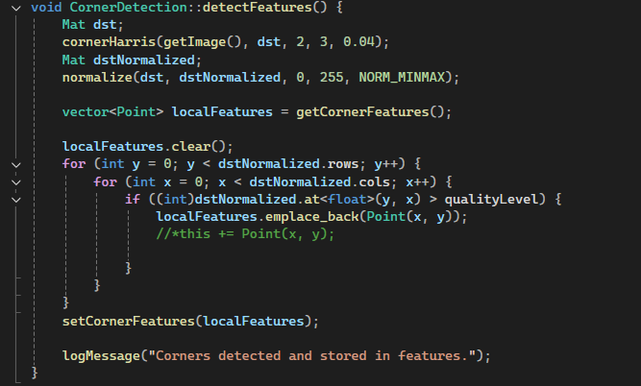

Figure detectFeatures

The **detectFeatures** function helps us find corner points here as in **LineDetection**. We detect corner points with the **cornerHarris** function in **OpenCV**. We get the image with **getImage().** dst is the output matrix, 2 is the block size around pixels, and 3 is the kernel size of the **sobel** filter. **dstNormalized** keeps the values ​​normalized between **0** and **255**. Again, the normalize function in **OpenCV** performs this function. **NORM_MINMAX** means that it will be normalized using the minimum and maximum values. The aim is to pull the values ​​between 0 and 255. The detected points are converted to a Point vector called **locakFeatures**. If the normalized value is greater than the **qualityLevel** Variable, the values ​​are transferred to the **localFeatures** vector. Then, the **localFeatures** values ​​are assigned from the local to the main variable with the set function. And finally, a log message is printed on the screen where the transaction is made.

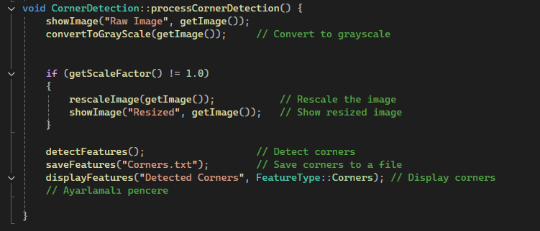

Figure processCornerDetection

Just like in **LineDetection**, each step is done in order and all steps are performed at this stage. First, the Raw Image is printed on the screen. Then, the Raw Image is converted to gray level with the help of the **convertToGrayScale()** function. Then, the **scaleFactor** variable is called with **getScaleFactor()** and the scale factor is checked. If the value is different from 1, the image is resized and the resized image is printed on the screen. Then, the corners are found with **detectFeatures()** and the corner value coordinates are written to Corners.txt with **saveFeatures("Corners.txt")**. Finally, the output is printed on the screen with the **disPlayFeatures()** function.

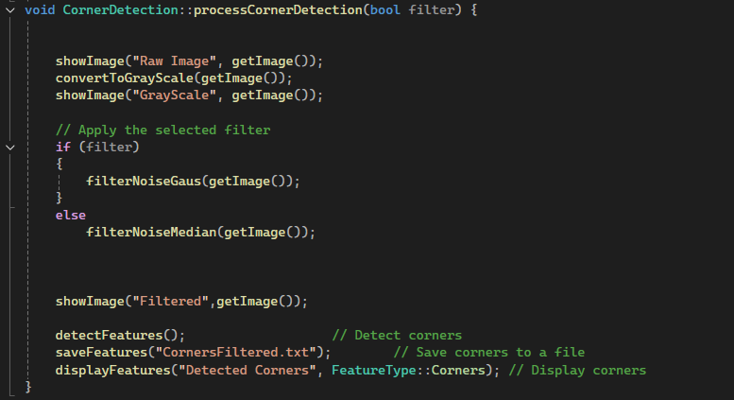

Figure Overloaded processCornerDetection

It takes a **bool** value as input and according to the selected **bool** value, if the value is **TRUE**, that is **1**, the **Gaussian filter** is applied with **filterNoiseGaus()**, if it is **FALSE**, that is **0**, the **median filter** is applied with **filterNoiseMedian()** and other operations continue the same.

**Main Code (Driver Code)**

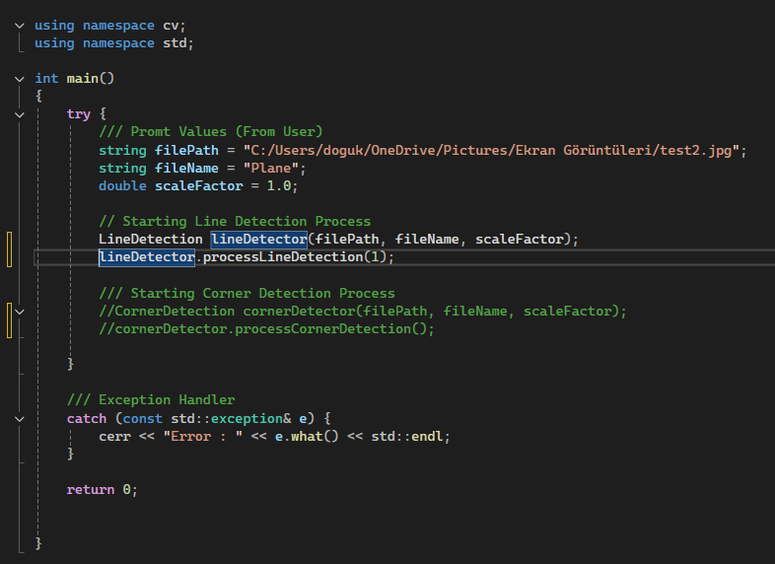

Figure Main Code

**RESULTS FOR LINE DETECTION**

**Input Raw Image**

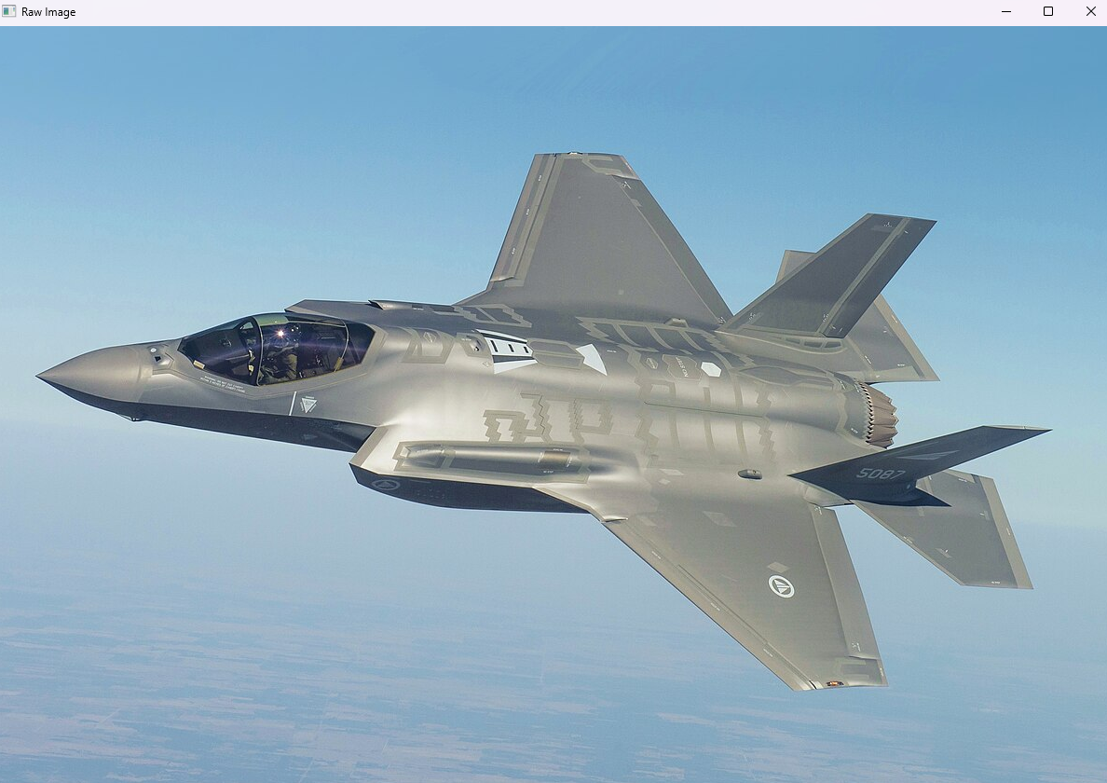

Figure Raw Image

**Gray Level Image:**

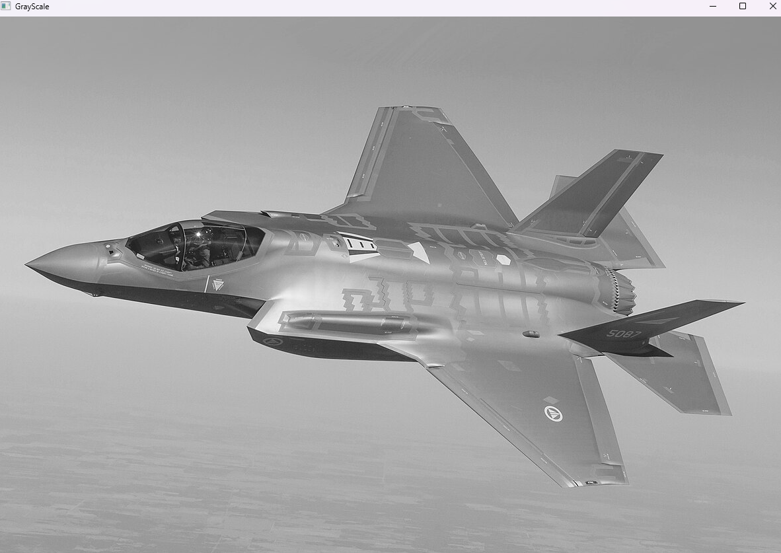

Figure 51 Gray Scaled Image

**Detected Lines Threshold = 100:**

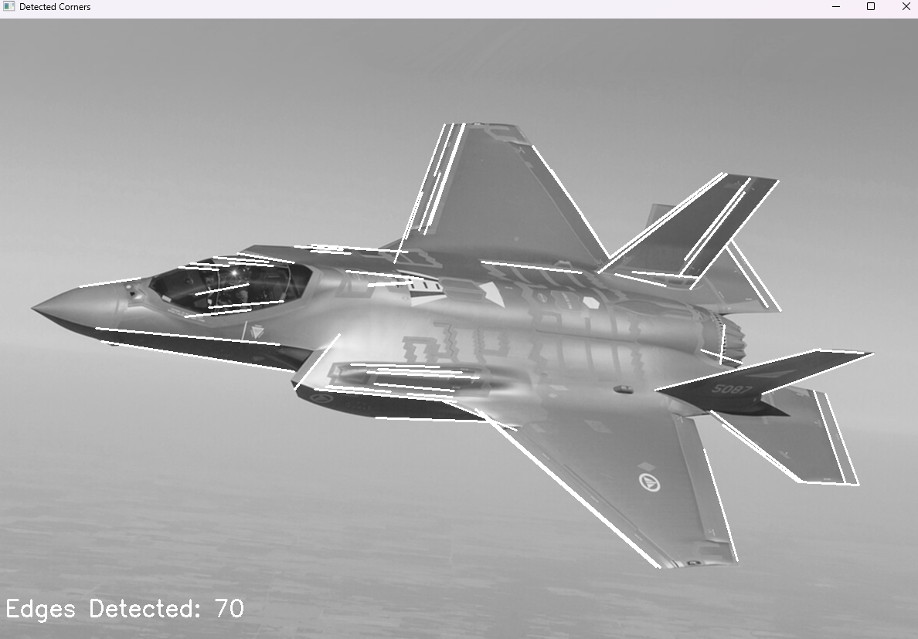

Figure 52 Detected Lines

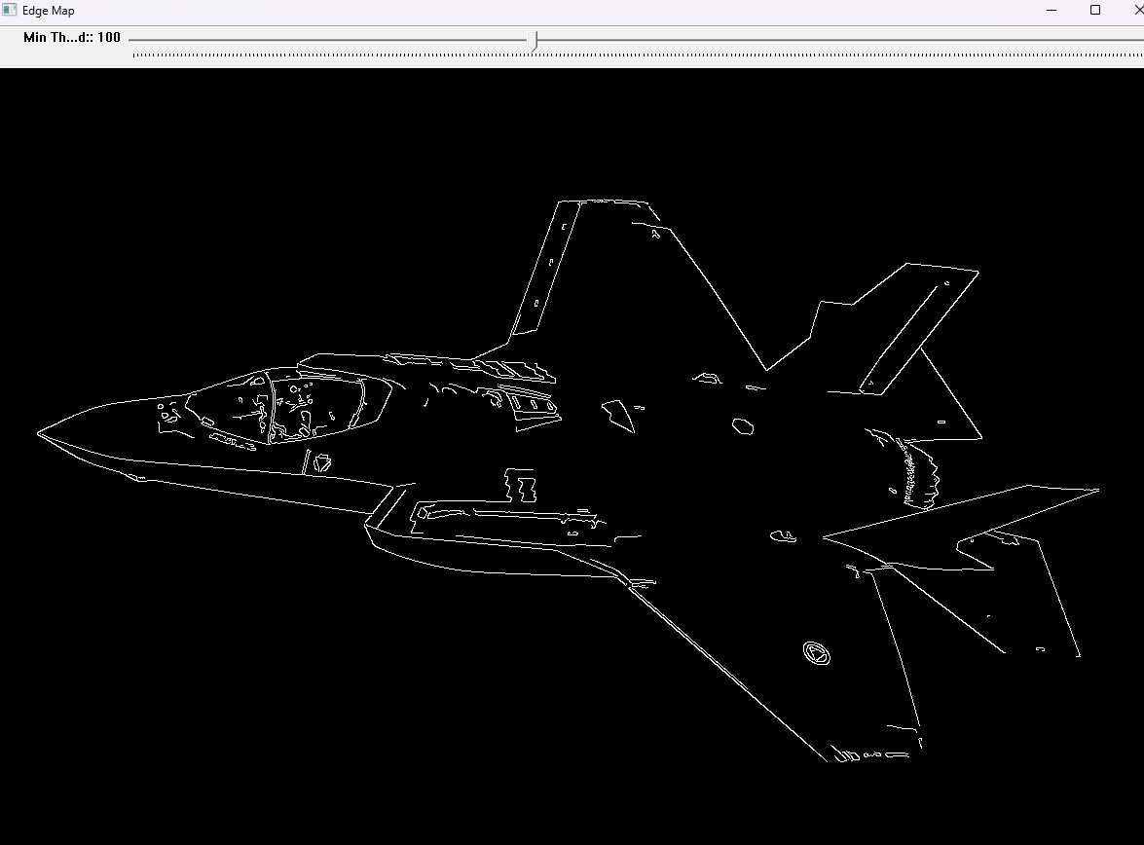

Figure 53 Edge Map

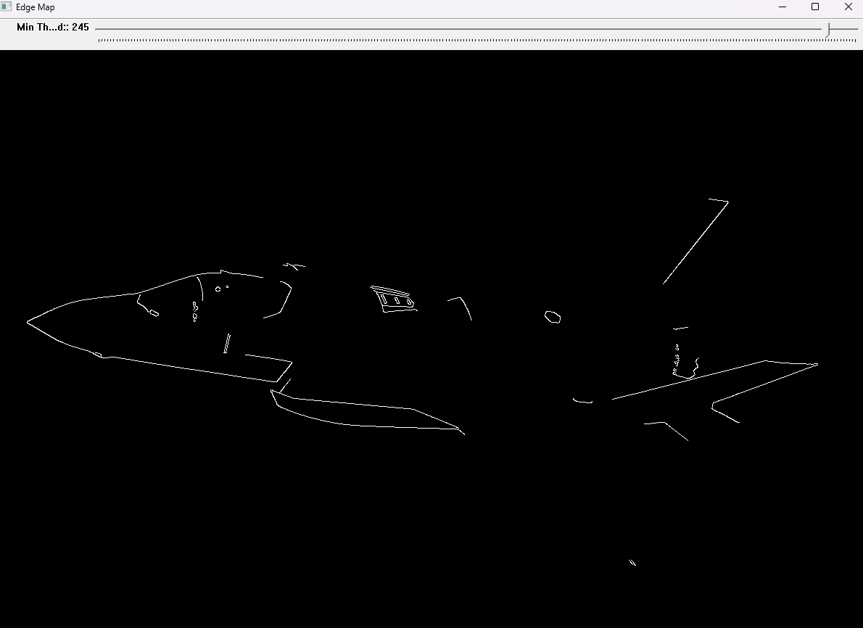**Detected Lines Threshold = 245:**

Figure 54 Edge Map 2

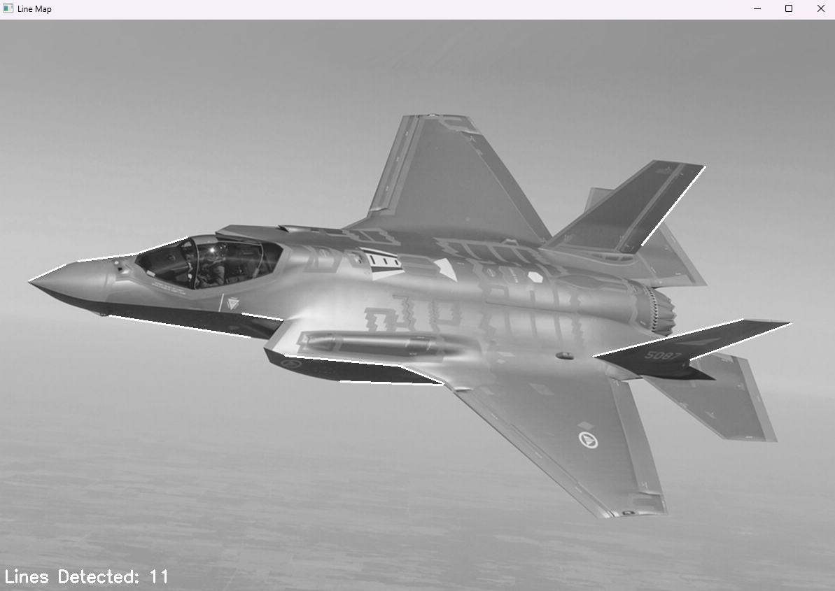

Figure 55 Detected Lines 2

**Detected Lines Threshold = 17 :**

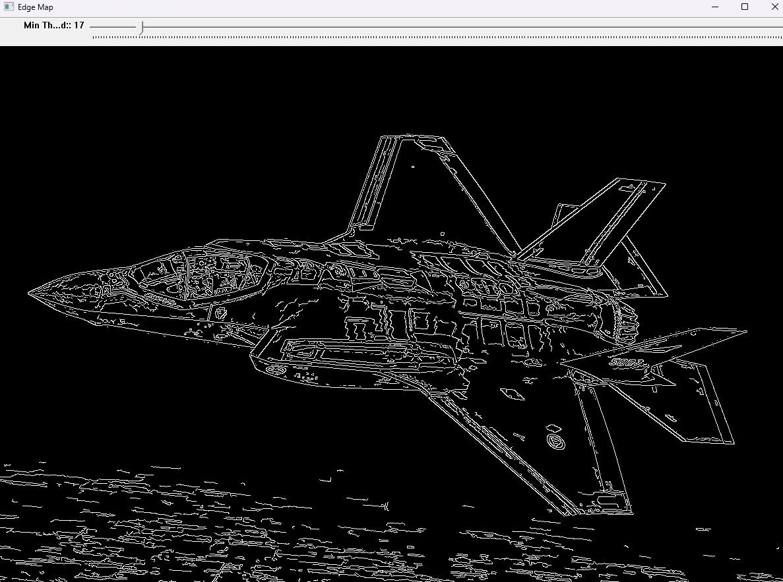

Figure 56 Edge Map 3

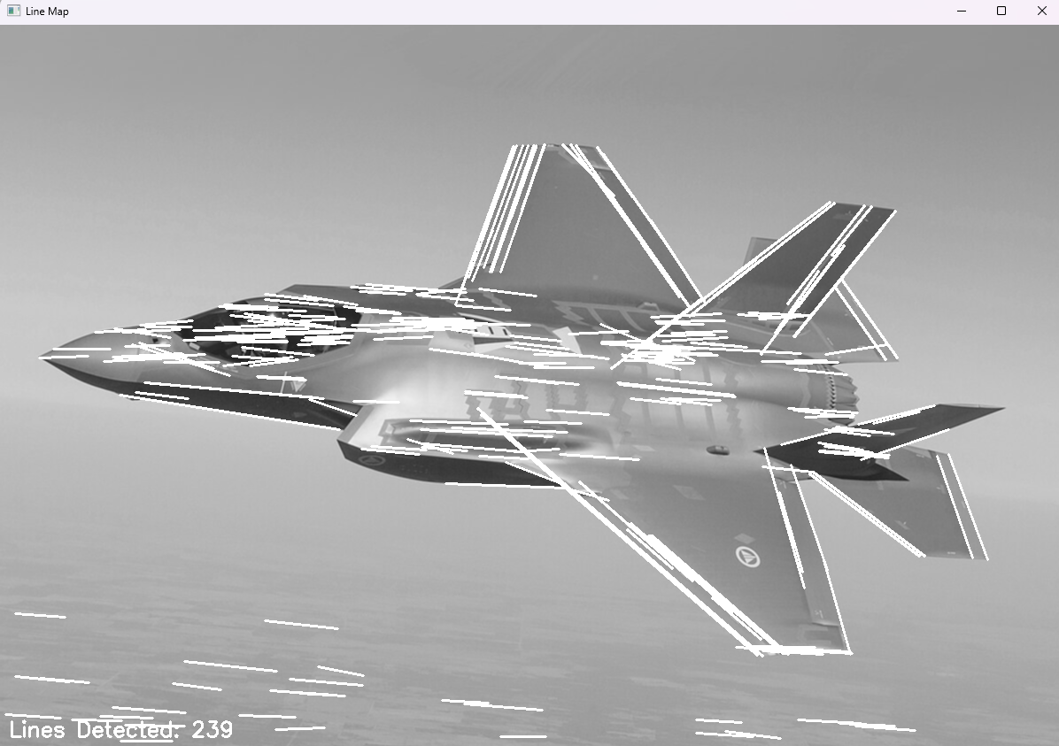

Figure 57 Lıne Detection 3

**RESULTS FOR CORNER DETECTION**

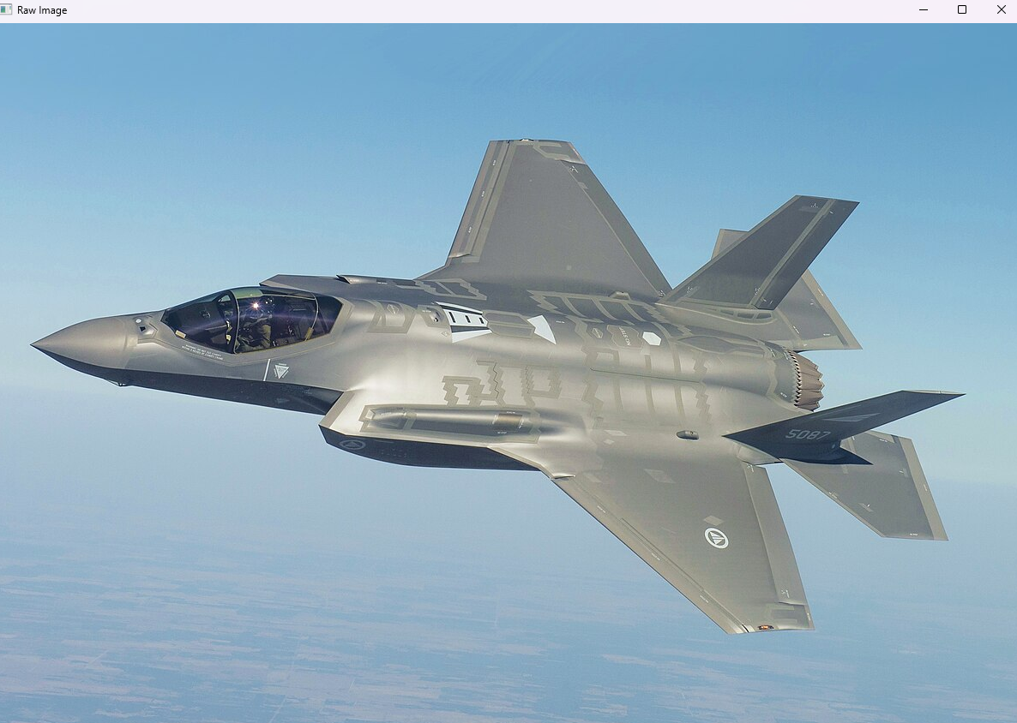

Figure 58 Input Raw Image

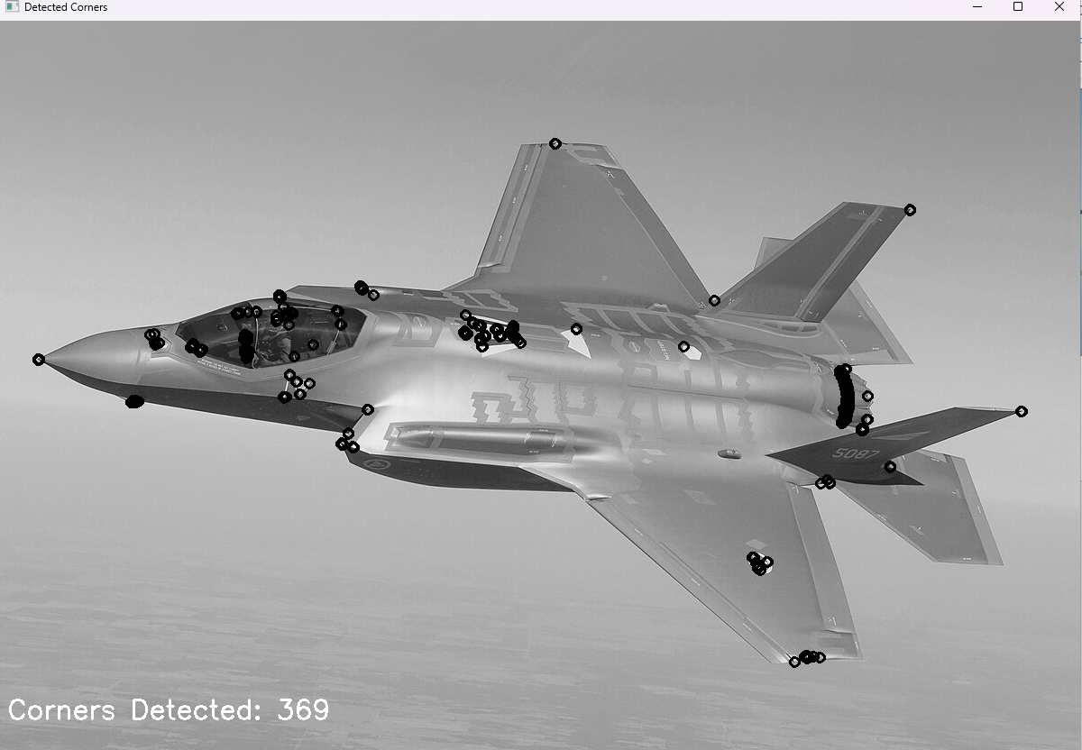**After Corner detection :**

Figure 59 Corner Detection